Caitlin Neppl & David Gelagay

Group 4: Paper Prototype

**Initial Meeting Notes**

Thursday, November 8, 6:30 PM

We met to discuss the design of the app and draw up some paper prototypes.

Discussion of menu possibilities takes place - we decide on bottom menu tabs with 3 or 4 options. Also talked in depth about what information would need to be available right away; as this is primarily a care app, decided that it would be good to have a queue type of display on start screen under greeting, so that user could see which plants are “up next” to get watered, and are able to click into the plant’s profile from the same screen.

Next we discussed what features should be available from within a plant’s profile as opposed to elsewhere in the app. Key was the question of whether an “add” function (of a new plant, diary entry/note, or image) should be implemented on the start screen, in the plant profile, or elsewhere. We decided a good place would be on one of the bottom tabs, alongside a calendar tab, plant search tab, and settings (including profile).

**Critical Areas**

Given that this app aims to assist new gardeners/plant-keepers, we thought that the three most critical areas of our design would have to go towards the goal of keeping the plants alive and well.

The first critical area is the calendar functionality - specifically the ability to set recurring watering reminders that would adjust depending on the user’s input regarding when they actually watered the plant.

The second critical area is the ability to add new plants. Users should be able to easily add new plants as well as plant info so they can begin the tracking process.

The third critical area is the profile. When a user opens a specific plant profile, we want to present them with information at a glance and options to change view or add an image.

**Study Tasks**

The main tasks we focused on were navigating from the front page to various places like the calendar or plant profile and adding a new plant.

First, a user is tasked with finding out which plant should be watered next. There are a variety of ways to get to this answer, but the easiest one is to just open the app, and look at the “check up on” section on the start screen. The plants are listed by the date of watering, and the plant with the most need will be listed at the very top.

Next, a user is tasked with adding a new plant to the collection. This is done by selecting the “add” tab along the bottom of the screen. A page is brought up that presents three options; the user selects “Add plant”. A new screen has several fill-in categories such as Display Name, picture selection, plant variety/species name, care information, and more.

Lastly, a user is tasked with navigating to the calendar which has all the plant watering schedules listed. From the main screen, all the user has to do is click on the calendar icon in the bottom menu and they are taken there.

**Paper Prototypes**

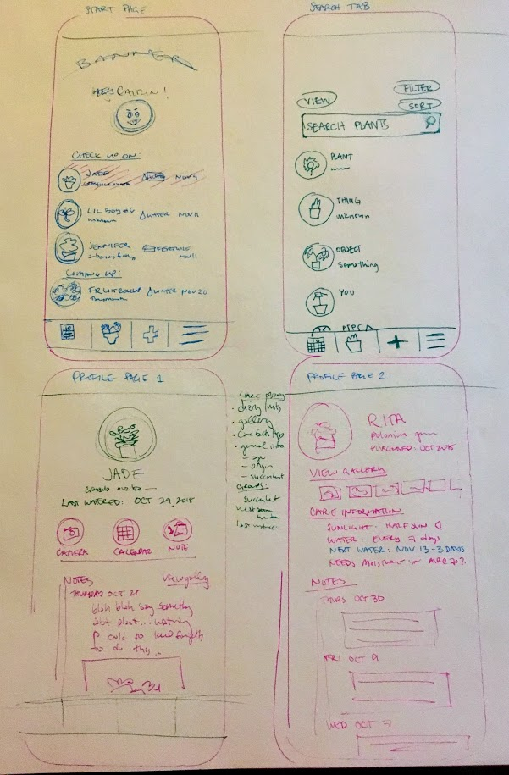

**Figma Link:** <https://www.figma.com/file/ZMIgLdCU9dhEi87xvYw7UjBI/plant-tracker-app?node-id=0%3A1>